# ***Design of Class A Four-Stage Audio Amplifier Using 2N3904 BJT***

*ID: 23702007*

*Md. Rakib Hasnat Akash*

For my project, I am designing a Class A audio amplifier using a four-stage BJT configuration with the **2N3904 NPN transistor**. The amplifier is intended to provide a gain greater than 200 (46dB) and a frequency response ranging from less than 10Hz to 1MHz. The stages are connected through RC coupling, with each stage contributing to the overall gain. To maintain high fidelity and minimize distortion, I have chosen a collector current (Ic) of 1mA. The amplifier will be powered by a 12Vdc supply, and the 2N3904 transistor will be used in the linear region as an amplifier to ensure clear signal amplification.

**Figure 1: The Amplifier**

This 4-stage cascaded Class A amplifier uses 2N3904 NPN transistors to amplify weak signals. Coupling capacitors (C2–C5) pass AC while blocking DC, maintaining biasing. Voltage divider networks (R1–R16) ensure stability. Collector resistors **(5.6kΩ)** set gain, and emitter resistors **(1kΩ)** provide feedback, reducing distortion. The output is taken from Q3’s collector via C5, powered by a **12V DC** supply.

**Simulation Results: Input and Output Waveforms:**

The input signal, designed to mimic a small audio signal, has an amplitude of 10 mV, a frequency of 1 kHz, and a DC offset of 0 V. The output waveform demonstrates the amplifier's ability to effectively amplify the input signal.

**Figure 2: Input Signal**

**Figure 3: Output Signal**

**Gain:**

The input signal has a peak-to-peak voltage of 20 mV, and the output signal has a peak-to-peak voltage of 5.7906 V. The voltage gain (Av) **is 289.53**, or **49.24 dB**. The current gain is calculated as **40.45**, using output current (28.814 μA) and input current (712.734 nA).

**Frequency Response:**

The 4-stage Class A amplifier shows an exponential gain rise up to 100 Hz, followed by a stable response until **20 kHz**, ensuring clear voice amplification (85–255 Hz). With a gain of 289.53 (49.24 dB), it effectively amplifies small signals. Beyond 100 kHz, the gain decreases due to parasitic effects, but this does not impact audio performance.

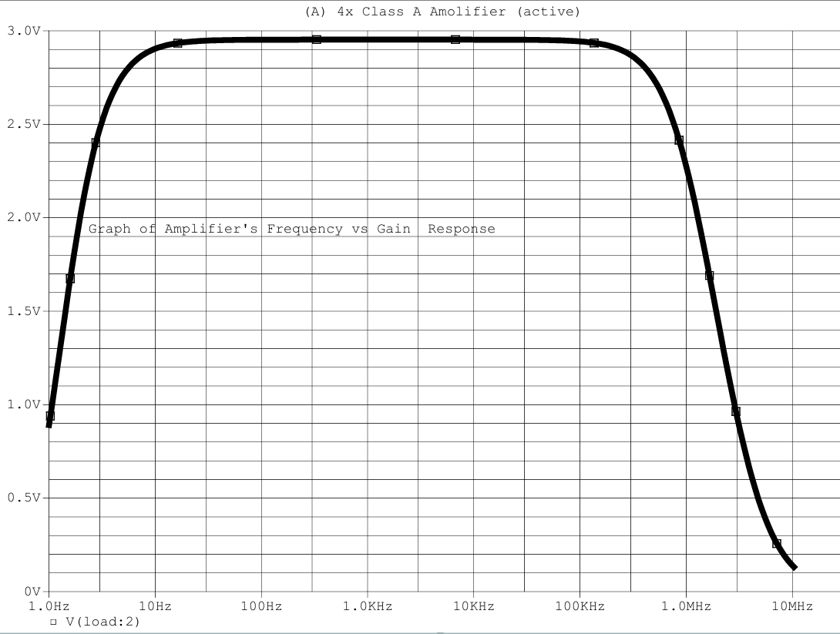

**Figure 4: Graph of Amplifier's Frequency vs Gain Response**

**Phase vs. Frequency Analysis for the Amplifier**

The phase shift begins at 0° at very low frequencies and decreases up to 30 Hz due to coupling capacitors blocking DC and low frequencies. Between **30 Hz and 100 kHz**, it remains stable, minimizing distortion and preserving signal integrity. Beyond 100 kHz, the shift increases due to capacitances, but this does not impact audio performance (20 Hz–20 kHz).

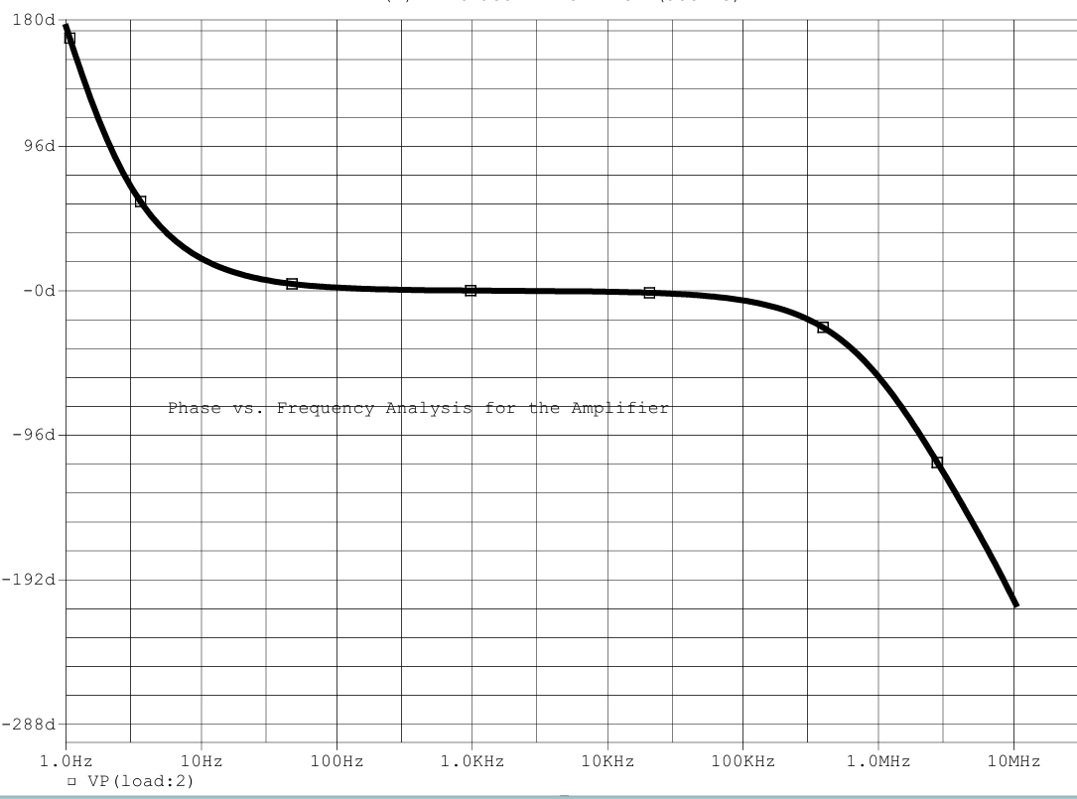

**Figure 5: Graph Illustrating Phase Shift**

**Total Harmonic Distortion (THD) Analysis**

The amplifier's THD is **0.75%** in the stable state (after 2s), ensuring minimal distortion and excellent audio quality. During the transient period (before 2s), THD reaches 50.01% due to settling effects and energy storage elements. The overall THD is 18.82%, but this is mainly influenced by transients and does not reflect steady-state performance.

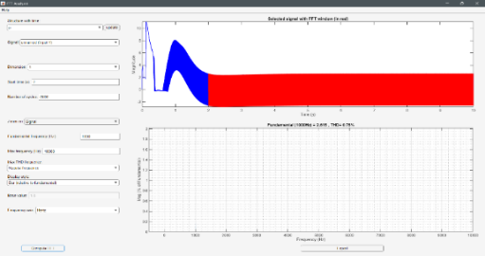

**Figure 6: Graph for Analyzing THD**

**Conclusion:**

The 4-stage Class A NPN common emitter amplifier demonstrated exceptional performance with a voltage gain of 289.53 and a current gain of 40.45. Its stable-state THD of 0.75% ensures minimal distortion, preserving signal integrity for high-quality amplification. The frequency response is flat up to 100 kHz, with stable phase response from 30 Hz to 100 kHz, ensuring minimal distortion across the audio range (20 Hz to 20 kHz). While gain decreases beyond 100 kHz due to parasitic capacitances, it remains effective for audio applications. Overall, the amplifier's high gain, low THD, and stable frequency response make it ideal for reliable audio amplification.